FLEXBOX
Flexbox = 1-dimensional layout
You control layout along one axis at a time (row or column).
Use Flexbox when items flow in one direction.

7.1 Flexbox Intro
To activate Flexbox:
.container {
display: flex;
}
That’s it.
Now:
Children become flex items
Layout follows flex rules
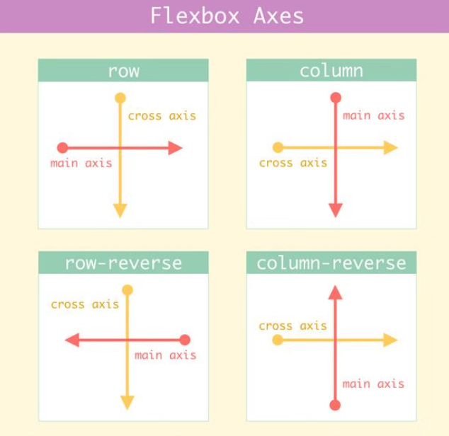

Flex Container

flex-direction
Defines main axis.
.container {
flex-direction: row; /* default */
/* column */
}
Values:
row → left → right
column → top → bottom
Everything in Flexbox is relative to main axis.

justify-content (MAIN AXIS)
Controls spacing along main axis.
.container {
justify-content: space-between;
}
Common values:
flex-start
center
space-between
space-around
space-evenly
“justify-content aligns items along the main axis.”

align-items (CROSS AXIS)
Controls alignment perpendicular to main axis.
.container {
align-items: center;
}
Values:
stretch (default)
center
flex-start
flex-end
“align-items aligns items along the cross axis.”

🔹gap (MODERN & CLEAN)
.container {
gap: 16px;
}
Space between items
Replaces margin hacks
Use gap, not margins, for spacing between flex items.

flex-wrap
.container {
flex-wrap: wrap;
}
nowrap (default)
wrap → moves items to next line
Used for:
Responsive cards
Image grids (simple)

Flex Items (CHILD LEVEL)

align-self
Overrides align-items for one item.
.item {
align-self: flex-end;
}
Used when one item behaves differently.

Common Flex Patterns

Center anything (INTERVIEW FAVORITE)
.container {
display: flex;
justify-content: center;
align-items: center;
}

Navbar layout
nav {
display: flex;
justify-content: space-between;
align-items: center;
}

Responsive cards
.cards {
display: flex;
flex-wrap: wrap;
gap: 16px;
}

GRID
Grid = 2-dimensional layout
You control rows and columns together.
Use Grid when layout is page-level or 2D.

Grid Intro
Activate Grid:
.container {
display: grid;
}
Now you control:
Columns
Rows
Placement

Grid Container

grid-template-columns
.container {
grid-template-columns: 1fr 1fr 1fr;
}
Creates 3 equal columns.

fr Unit (FRACTIONAL UNIT)
grid-template-columns: 2fr 1fr;
Means:
First column = 2 parts
Second = 1 part
Senior rule
fr distributes available space intelligently.

gap
.container {
gap: 20px;
}
Works for:
Rows
Columns

Auto-fit / Auto-fill (RESPONSIVE MAGIC – BASIC)
.container {
grid-template-columns: repeat(auto-fit, minmax(250px, 1fr));
}
What happens:
As screen grows → more columns
As screen shrinks → fewer columns
Used for:
Product grids
Dashboards
Image galleries

Grid 12-Column Layout (CONCEPT)
Common in:
Bootstrap
Dashboards
grid-template-columns: repeat(12, 1fr);
Then items span columns (conceptually):
Sidebar: 3 columns
Content: 9 columns
You’ll use this mentally, even in frameworks.

Grid Items
You can place items explicitly, but don’t overdo it early.
.item {
grid-column: span 2;
}
Let Grid auto-place unless needed.

